**SQL vs SPARQL Queries side by side**

Author: Marcelo Barbieri  
Date: **08/03/2015**

Contents

Microsoft Northwind sample database (ER Diagram) 2

Basic Select with Specified Columns 3

Filtering Data on Exact String Comparison 5

Filtering Data on String Comparison (LIKE vs REGEX) 7

Using Logical Operators 9

Selecting Data Ranges 12

Filtering on List of Values 14

Working with NULL Values In this example, Suppliers with and without Fax number. Yeap, some people still use them. 16

Sorting Data 22

Eliminating Duplicates 24

Using Alias and String Concatenation 26

Selecting Top Values 28

Counting Records 30

Counting Records on Specific Column (ignores null values) 31

Grouping Data 32

## Microsoft Northwind sample database (ER Diagram)

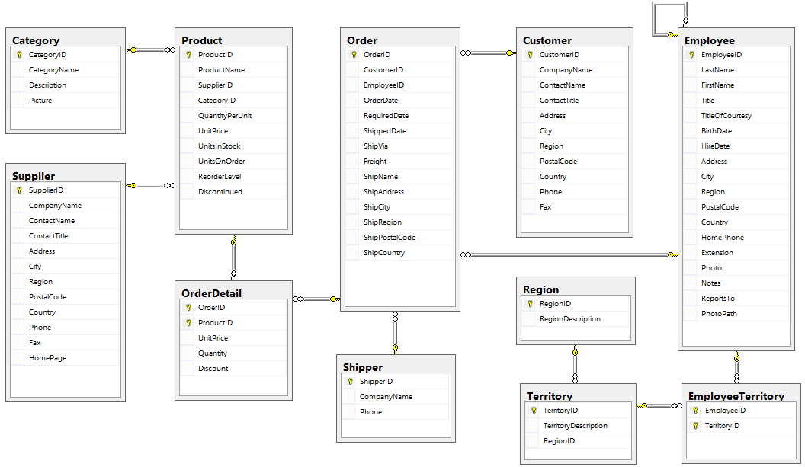

## Basic Select with Specified Columns

**SQL on SQL Server**

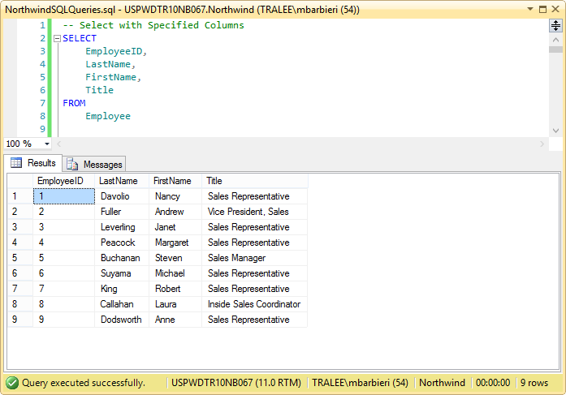

**SPARQL on GraphDB**

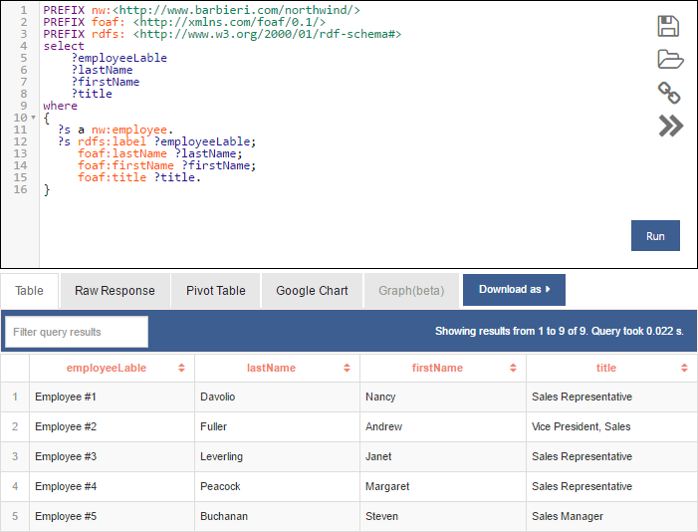

**Total of 9 records.**

## Filtering Data on Exact String Comparison

**SQL on SQL Server**

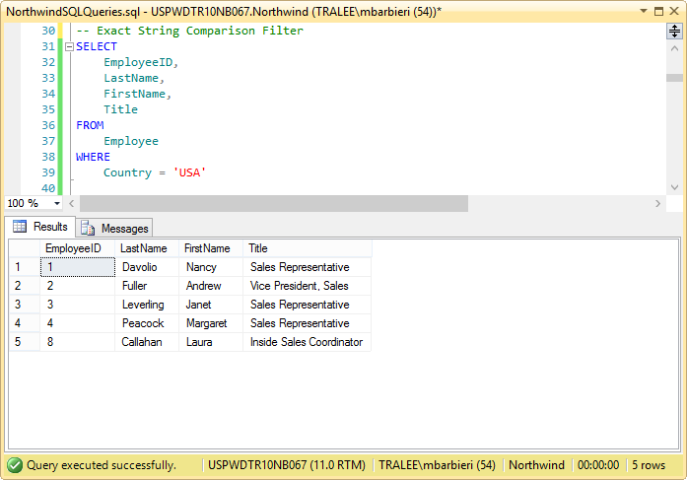

**SPARQL on Stardog**

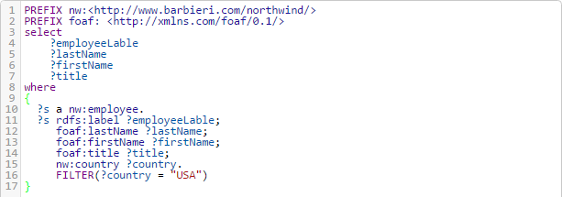

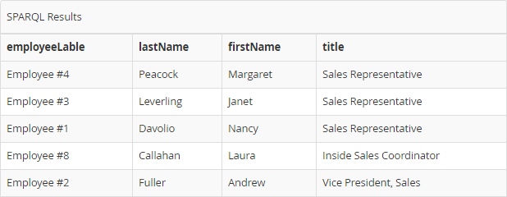

## Filtering Data on String Comparison (LIKE vs REGEX)

**SQL on SQL Server**

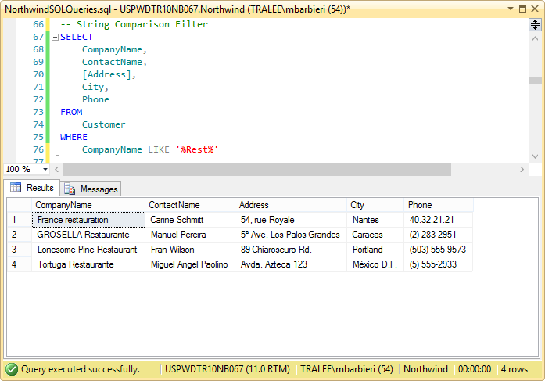

**SPARQL on GraphDB**

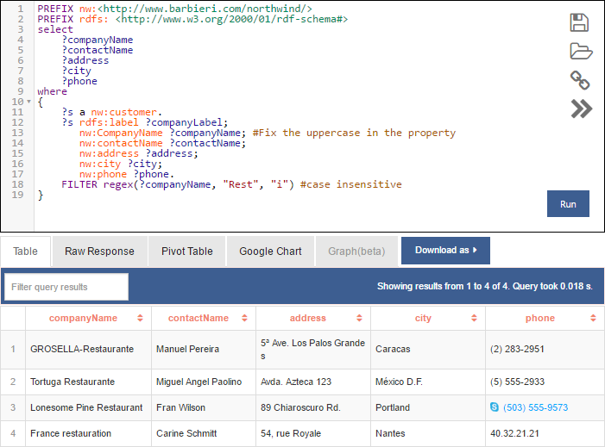

## Using Logical Operators

**SQL on SQL Server**

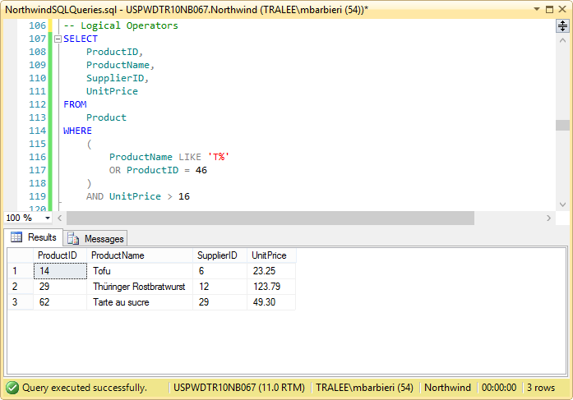

**SPARQL on GraphDB**

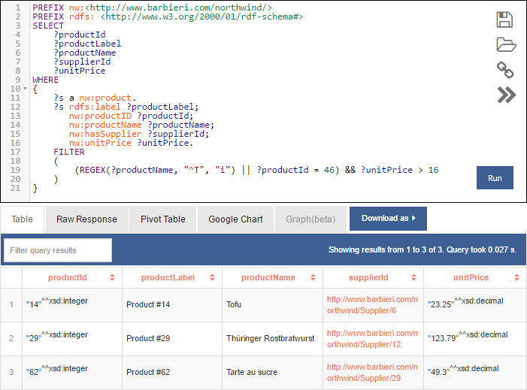

**Note that the SupplierId in the result set above contains URIs, which will be used to get the remaining Supplier Properties later on.**

**Integer and Decimals converted to String**

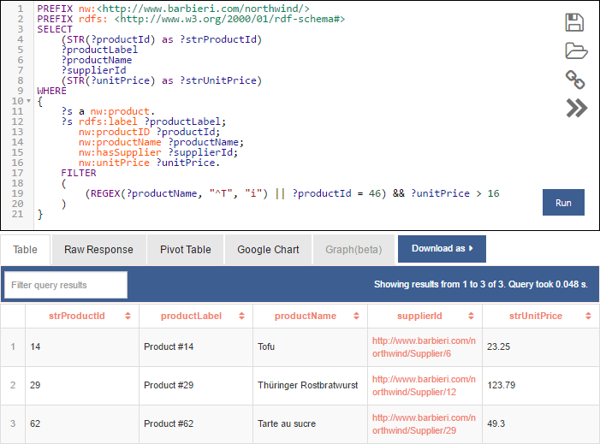

## Selecting Data Ranges

**SQL on SQL Server**

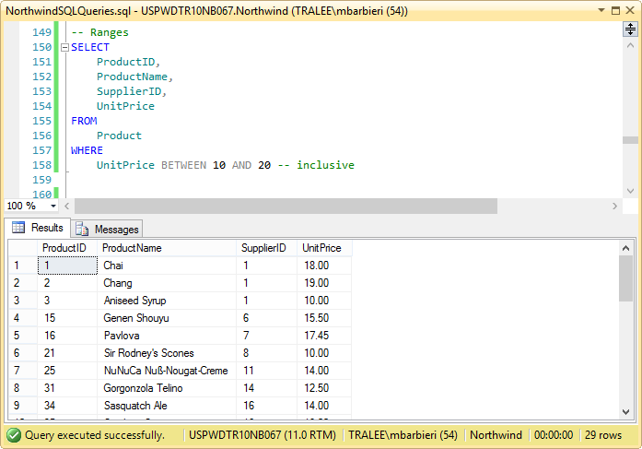

**SPARQL on GraphDB**

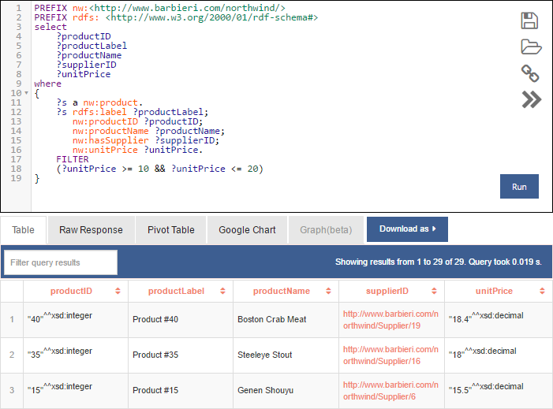

**29 items in the result set.**

## Filtering on List of Values

**SQL on SQL Server**

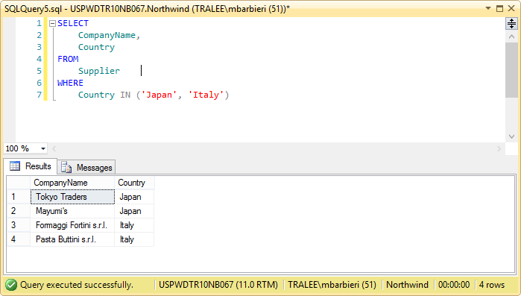

**SPARQL on GraphDB**

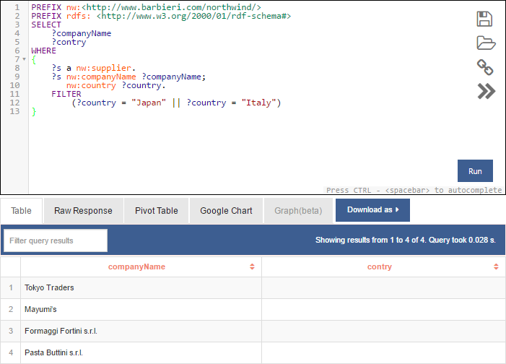

## Working with NULL Values In this example, Suppliers with and without Fax number. Yeap, some people still use them.

**SQL on SQL Server**

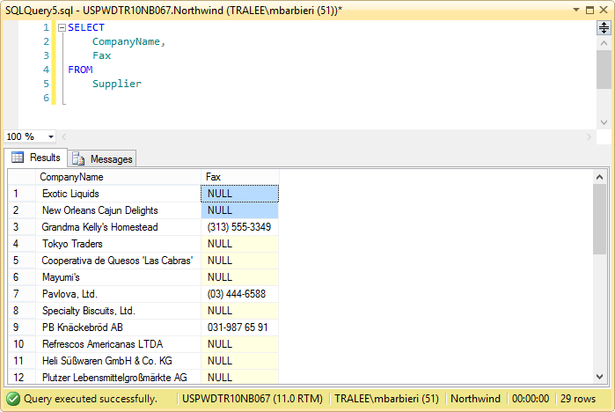

**SPARQL on GraphDB**

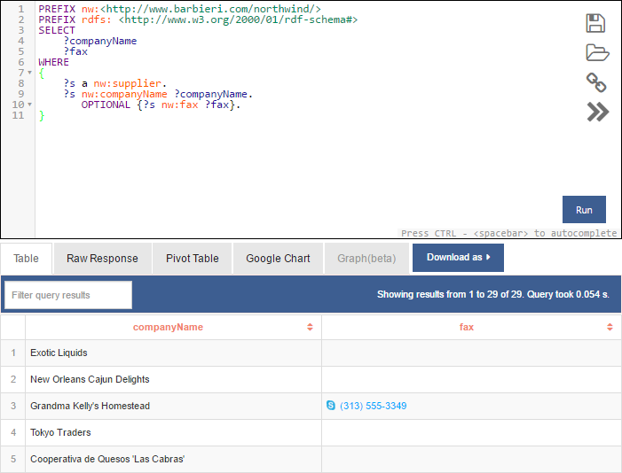

**SQL on SQL Server**

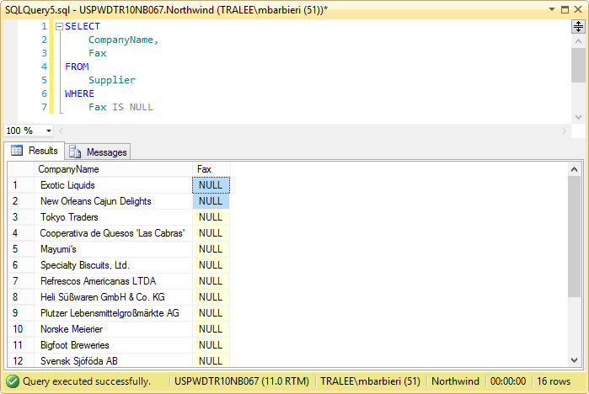

**SPARQL on GraphDB**

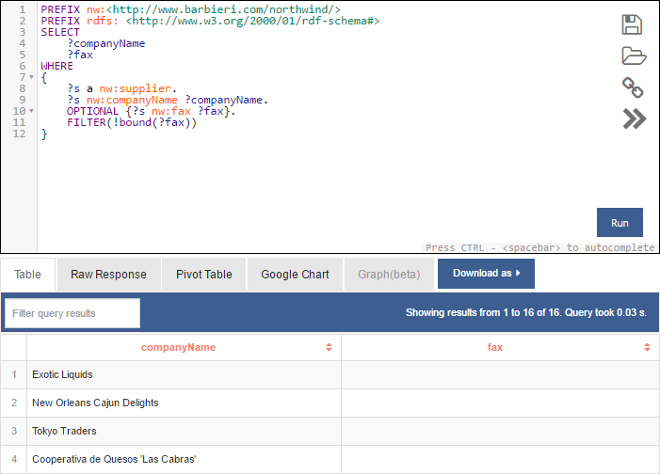

**SQL on SQL Server**

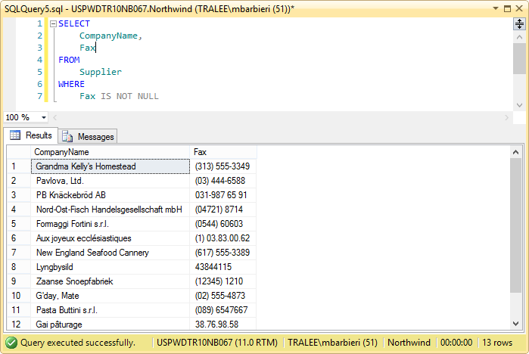

**SPARQL on GraphDB**

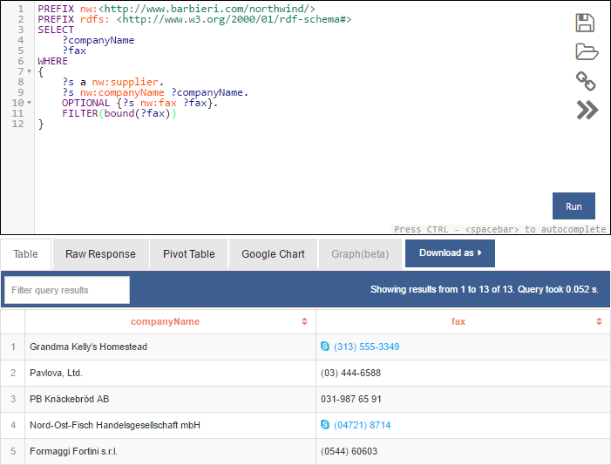

## Sorting Data

**SQL on SQL Server**

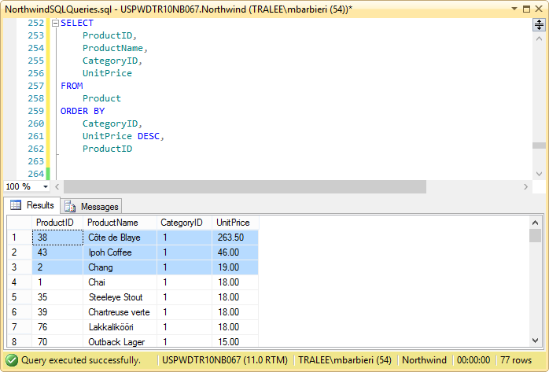

**SPARQL on GraphDB**

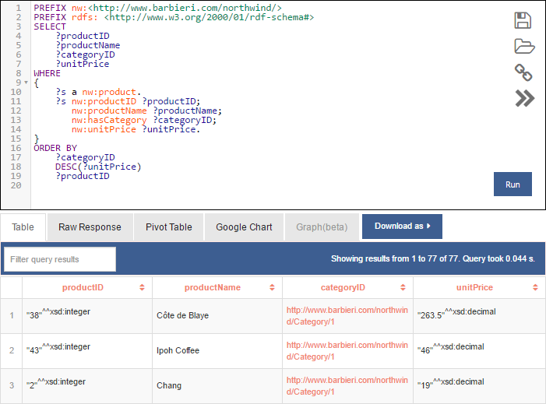

## Eliminating Duplicates

**SQL on SQL Server**

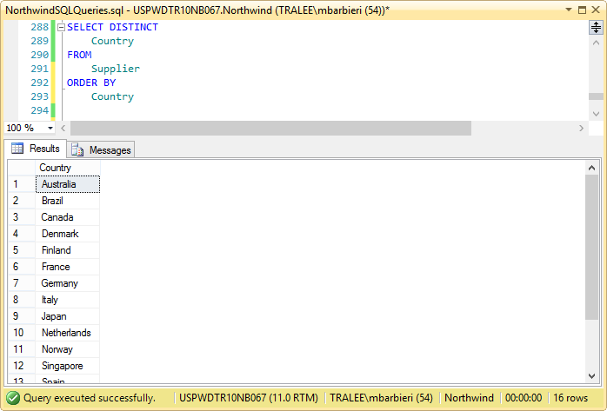

**SPARQL on GraphDB**

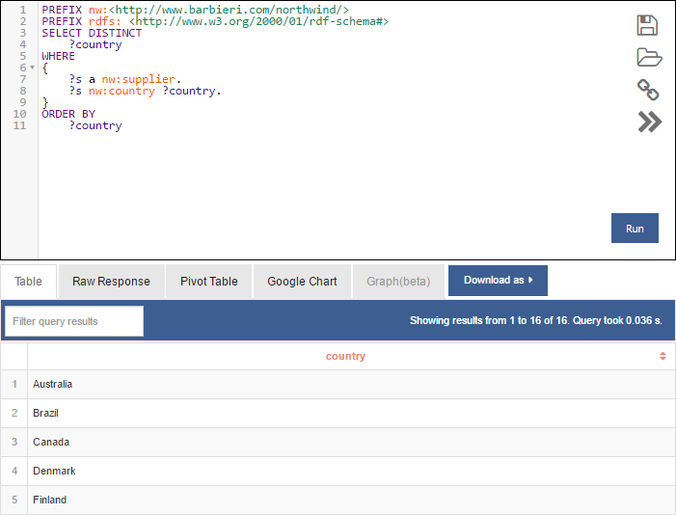

## Using Alias and String Concatenation

**SQL on SQL Server**

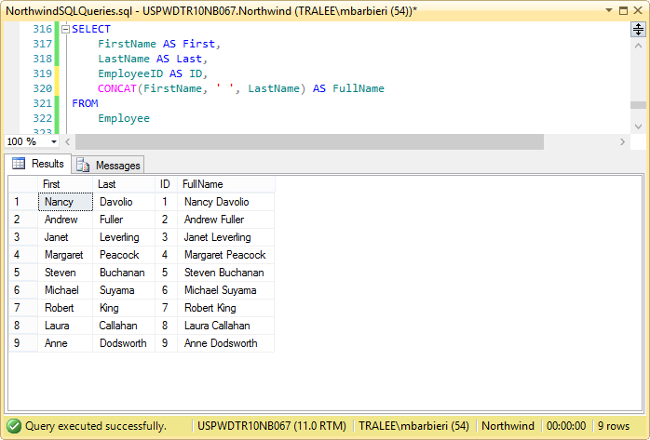

**SPARQL on GraphDB**

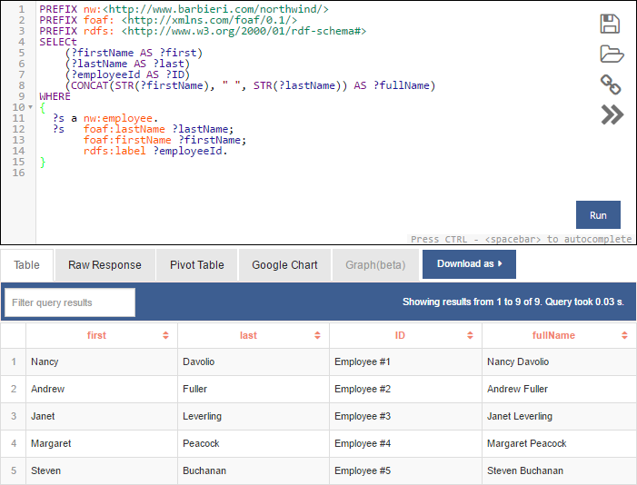

## Selecting Top Values

**SQL on SQL Server**

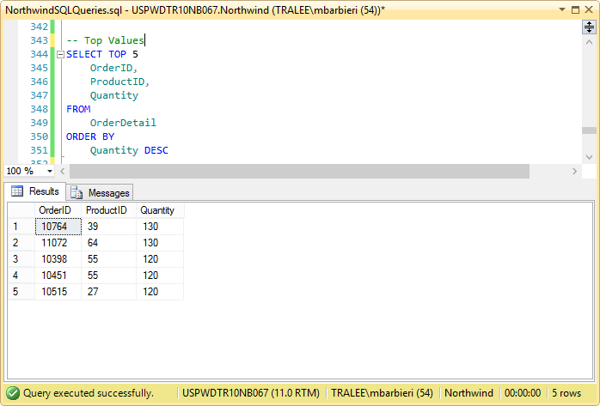

**SPARQL on GraphDB**

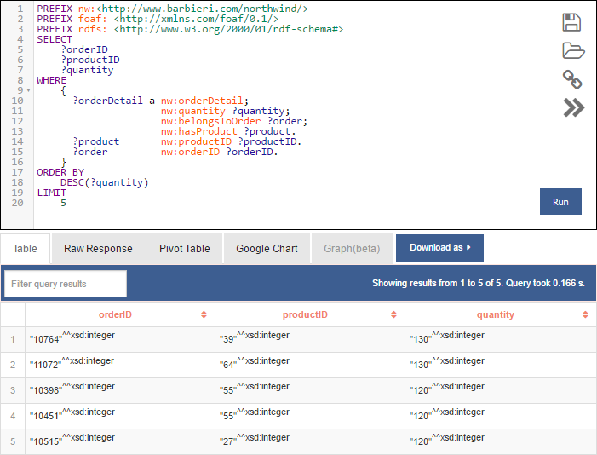

## Counting Records

**SQL on SQL Server**

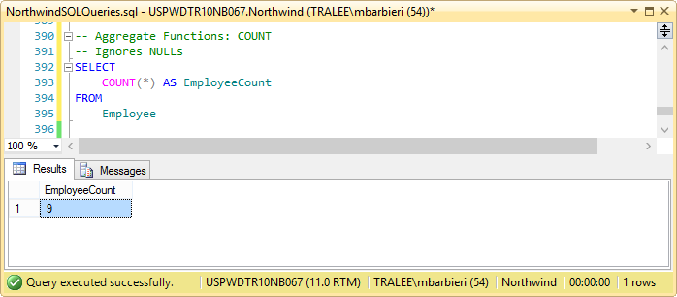

Note: One Employee doesn’t report to anybody, and therefore ReportsTo is NULL.

**SPARQL on GraphDB**

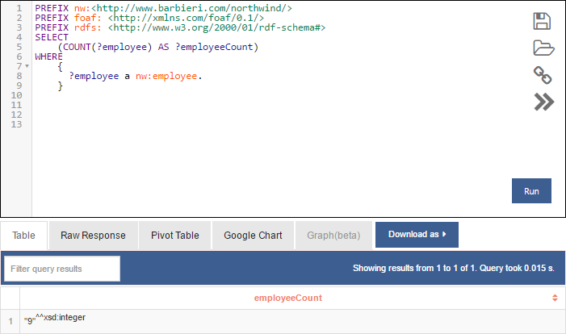

## Counting Records on Specific Column (ignores null values)

**SQL on SQL Server**

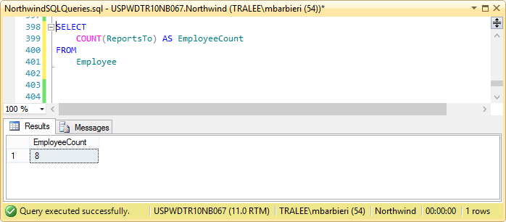

**SPARQL on GraphDB**

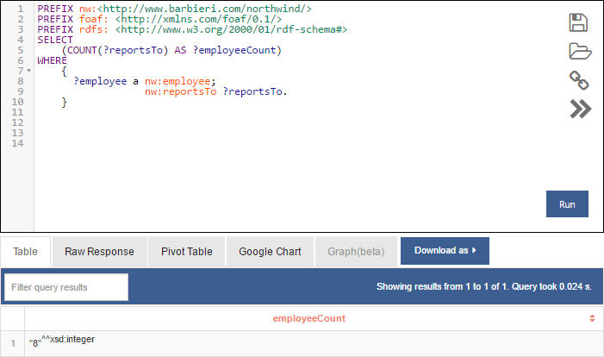

## Grouping Data

**SQL on SQL Server**

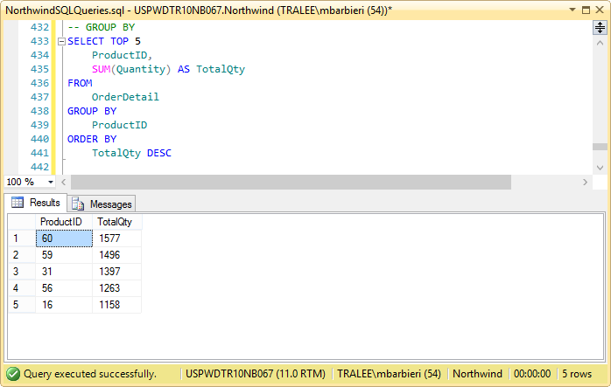

**SPARQL on GraphDB**

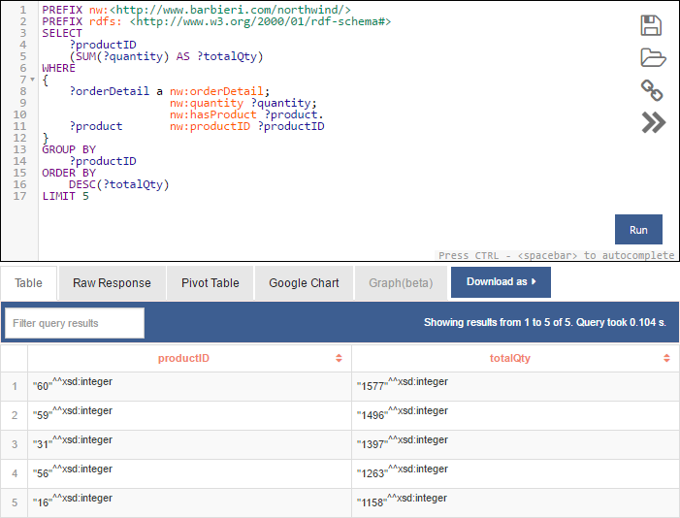

**SPARQL on GraphDB (Pivot Table)**

